1.Install NumPy in your Python environment using pip, then create a Python file called insta_likes.py and import numpy as np at the top.

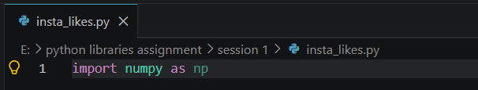

2.Create a NumPy array called followers using np.array() that stores the follower counts for 5 Instagram influencers: [1200, 15000, 67000, 340000, 1250000]. Print the array, its shape, number of dimensions, and data type.
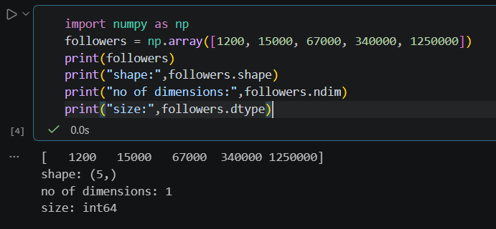

3.Use np.arange() to generate an array of order IDs for 10 consecutive Zomato orders starting from 101. Print the array and its size.

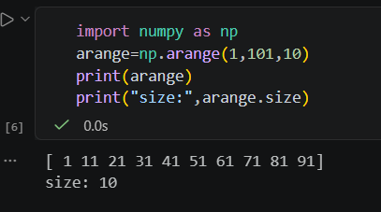

4.Create a 3x3 NumPy array using np.eye() to represent a 'like' identity matrix for a new Spotify playlist feature. Print the matrix and explain what the diagonal values represent in a comment.
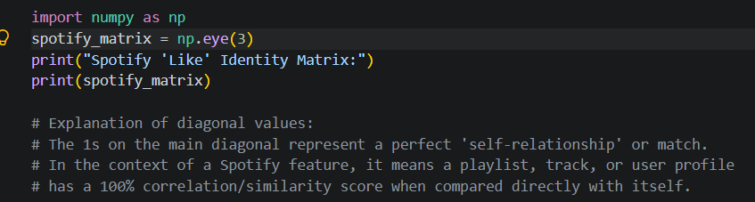

5.Convert a Python list of cricket scores [45, 67, 120, 89, 54] to a NumPy array, then use the .itemsize attribute to print how many bytes each score takes in memory. Use np.array() for conversion and .itemsize for memory size.

